MINI PROJECT-BOLLYWOOD SEARCH ENGINE USING WEBSCRAPING

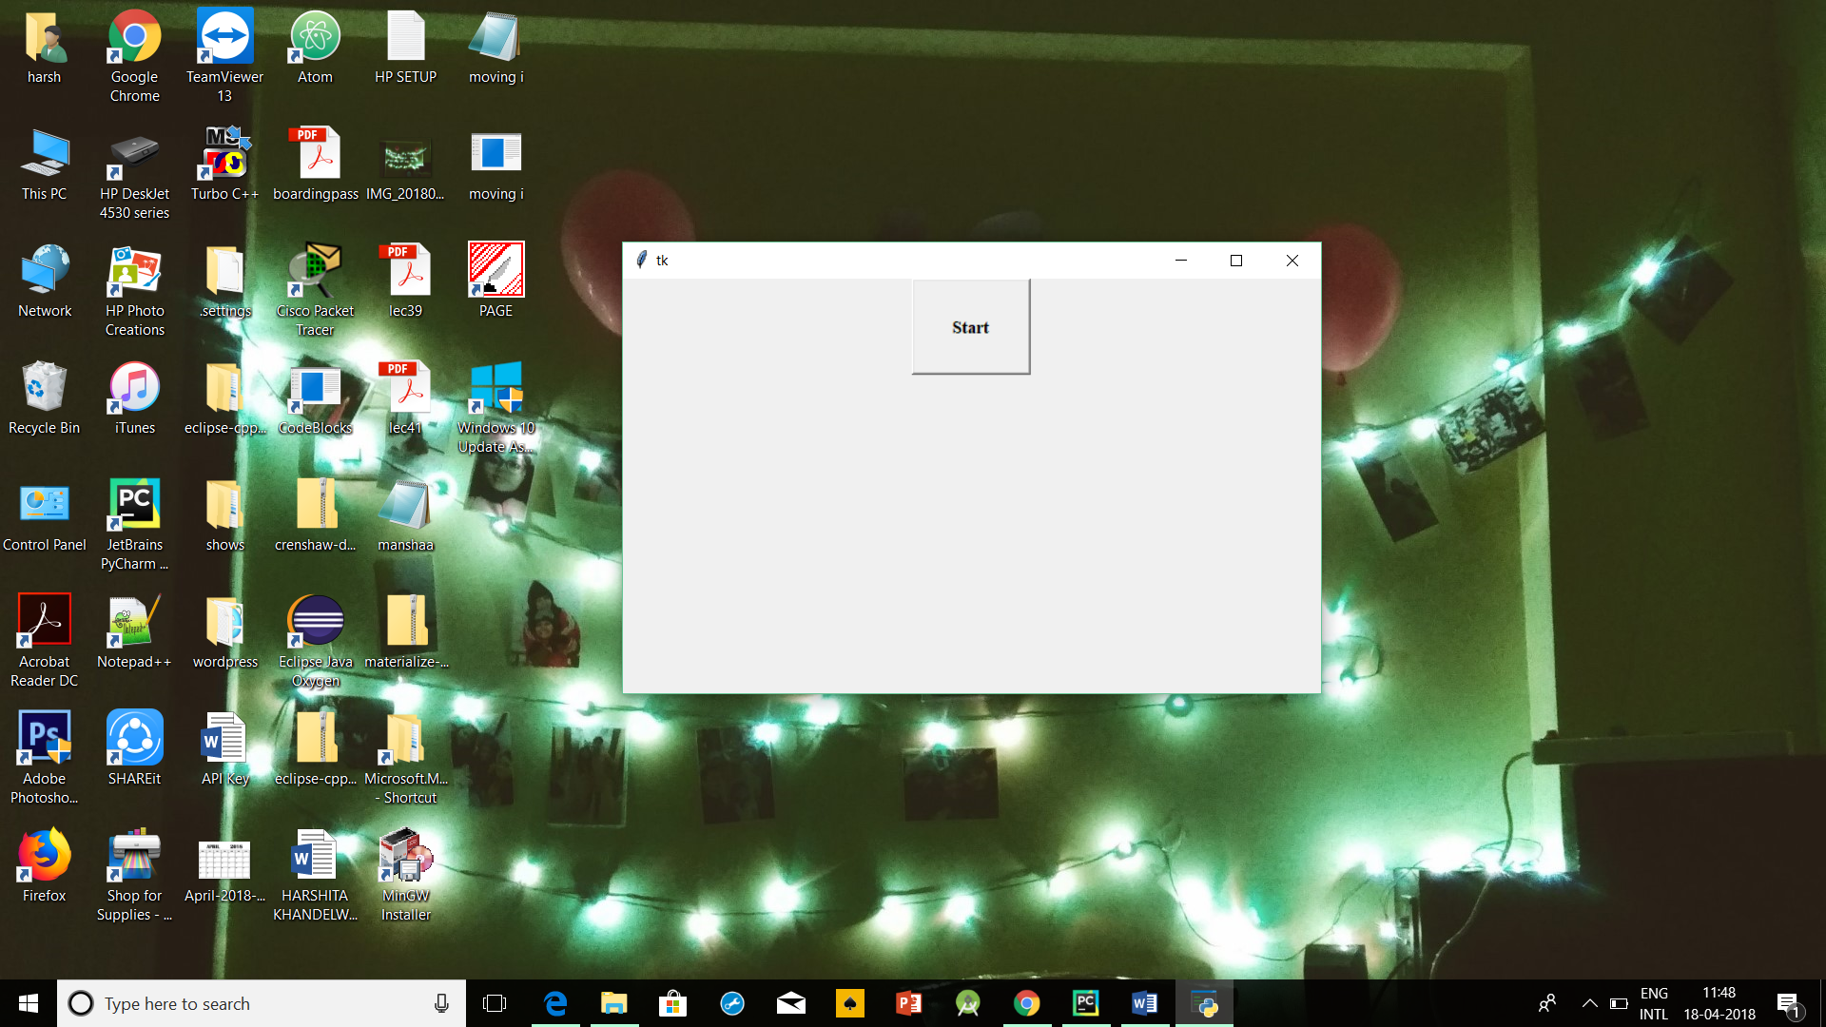

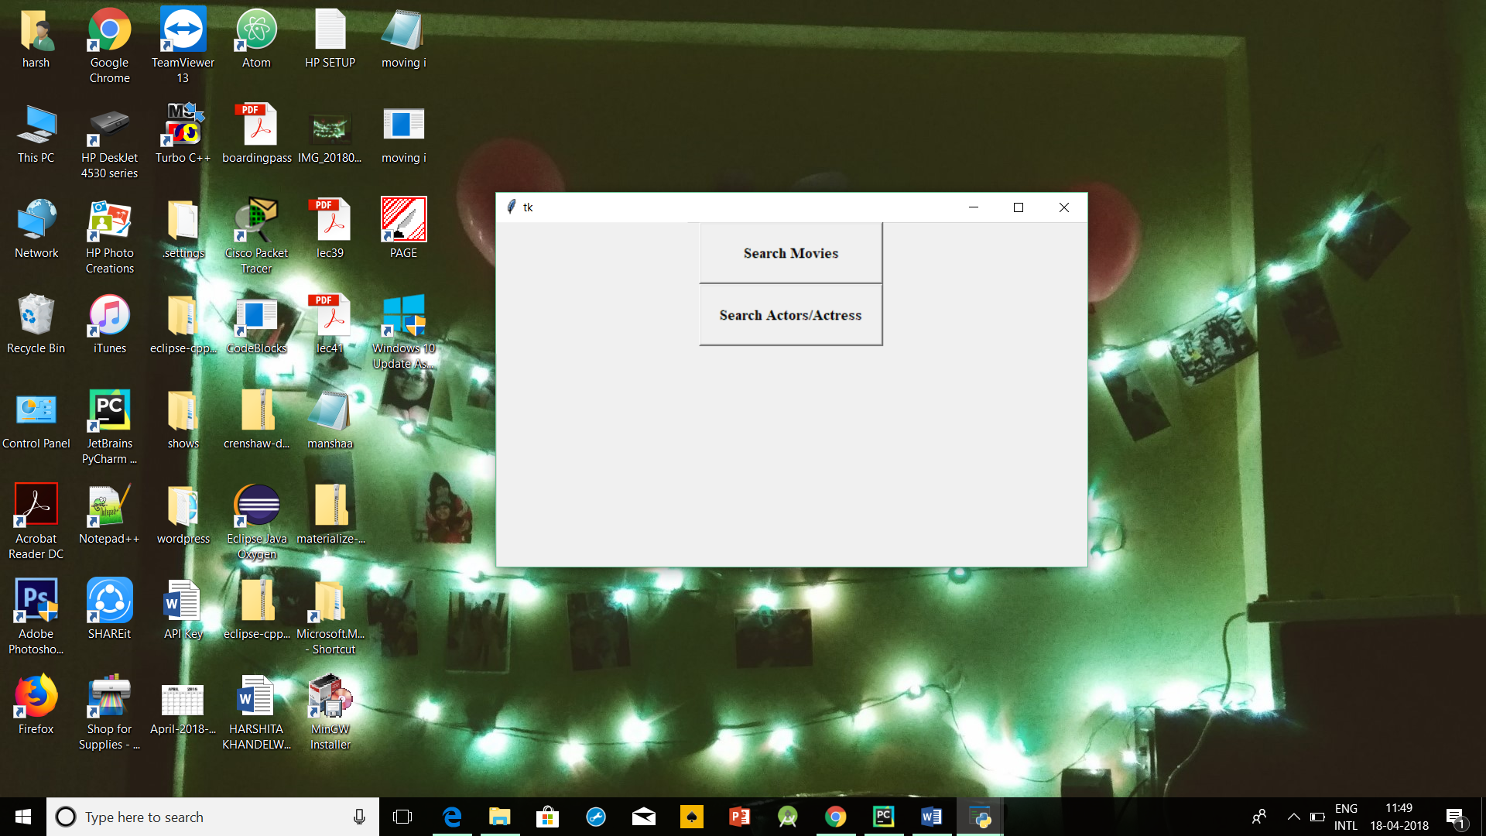

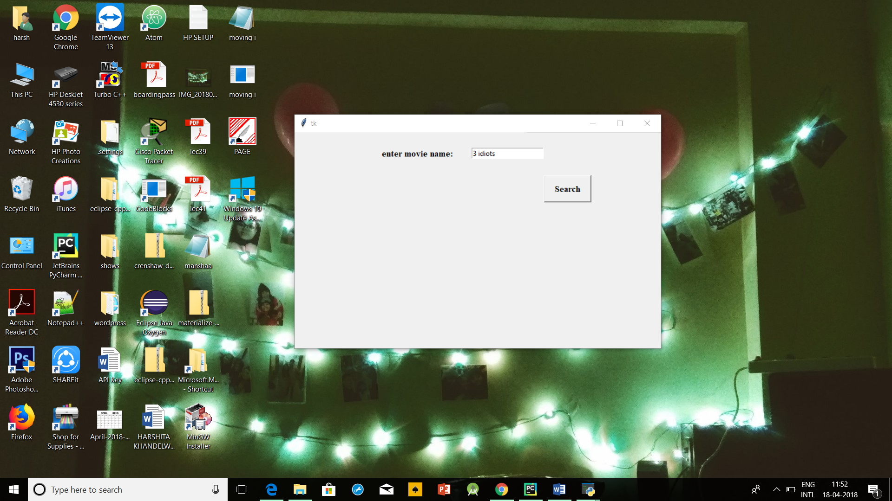

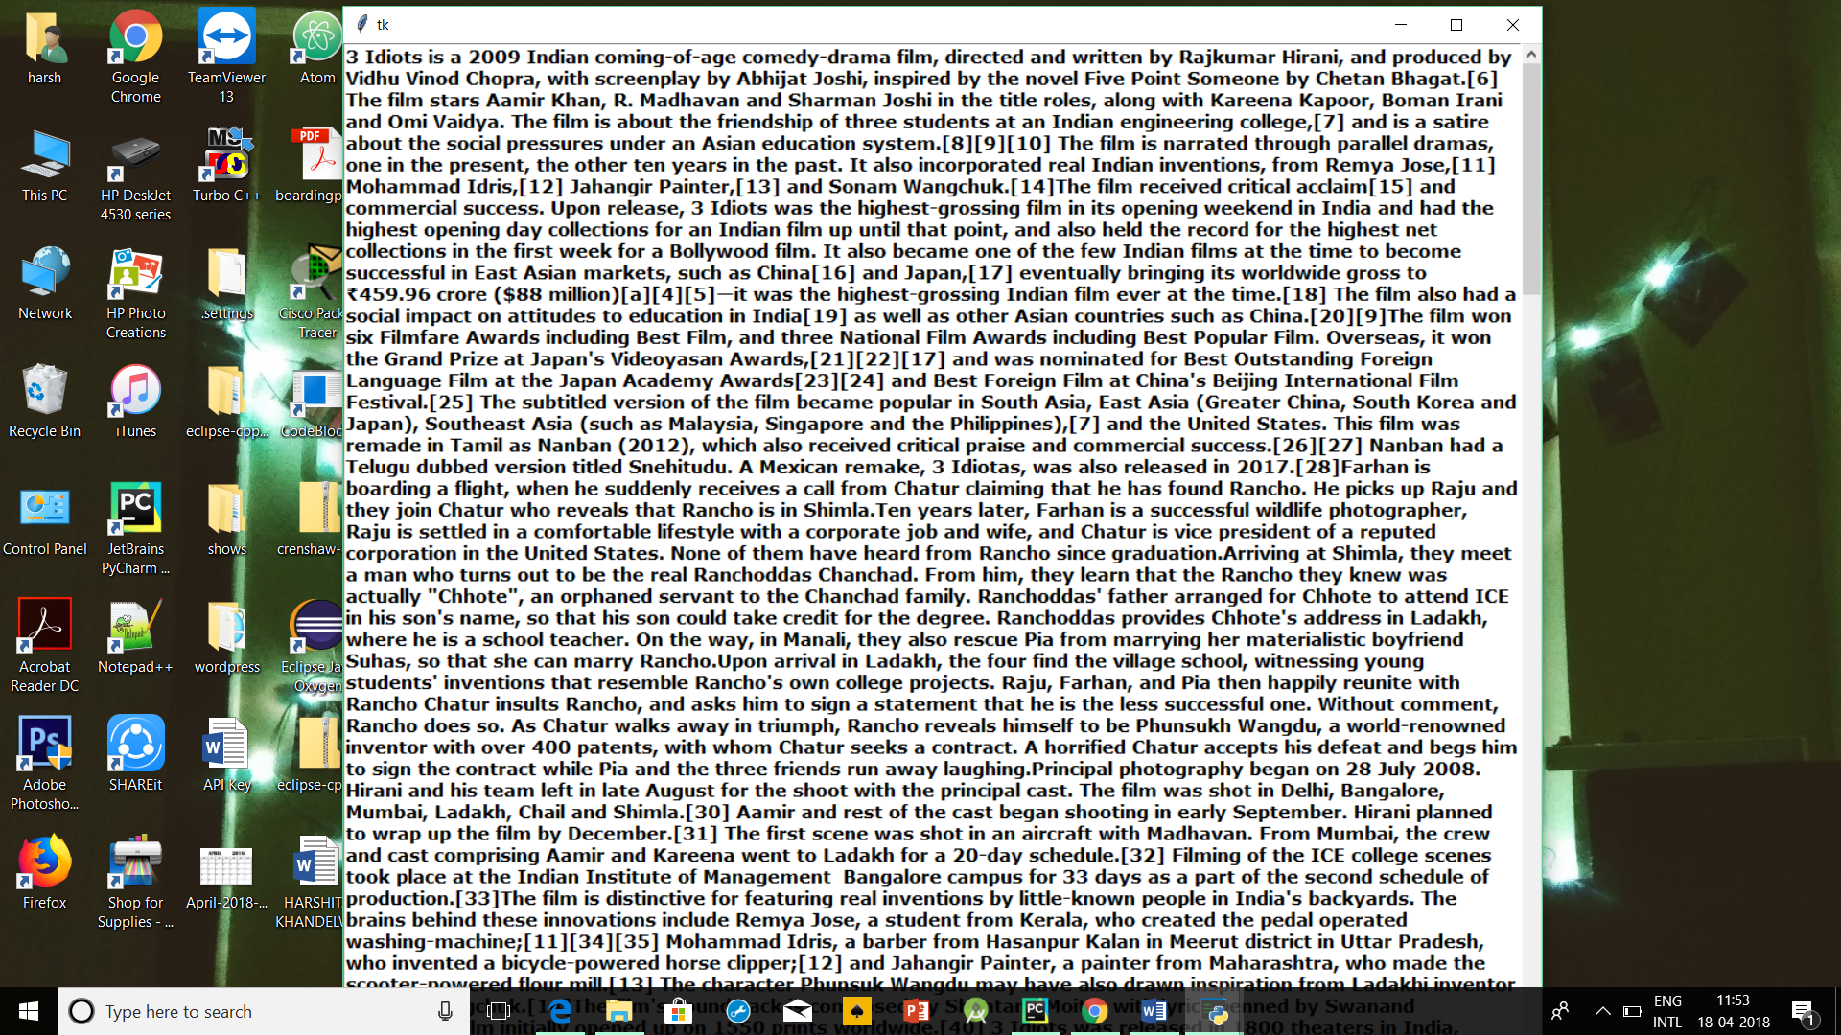

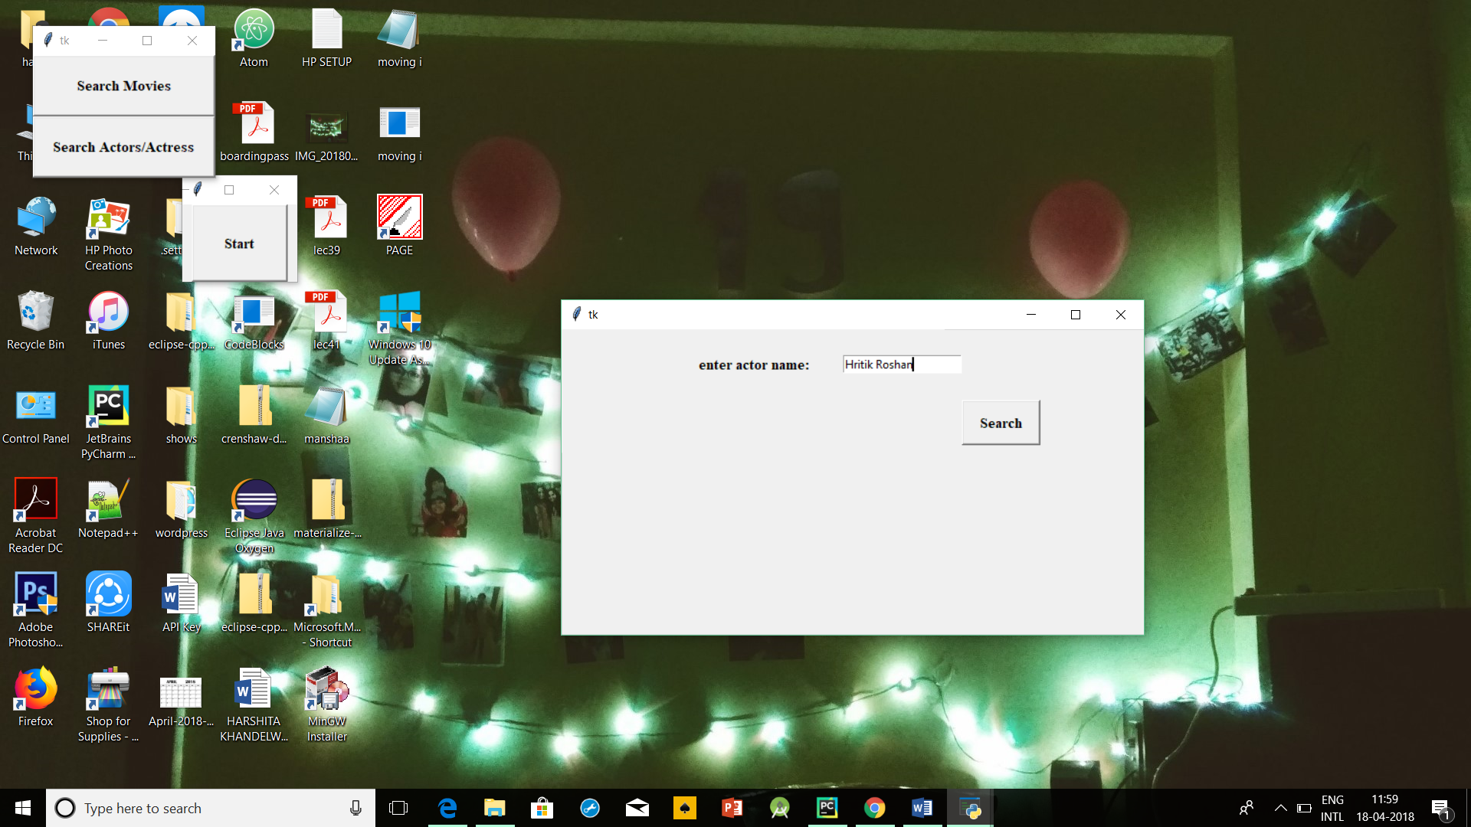

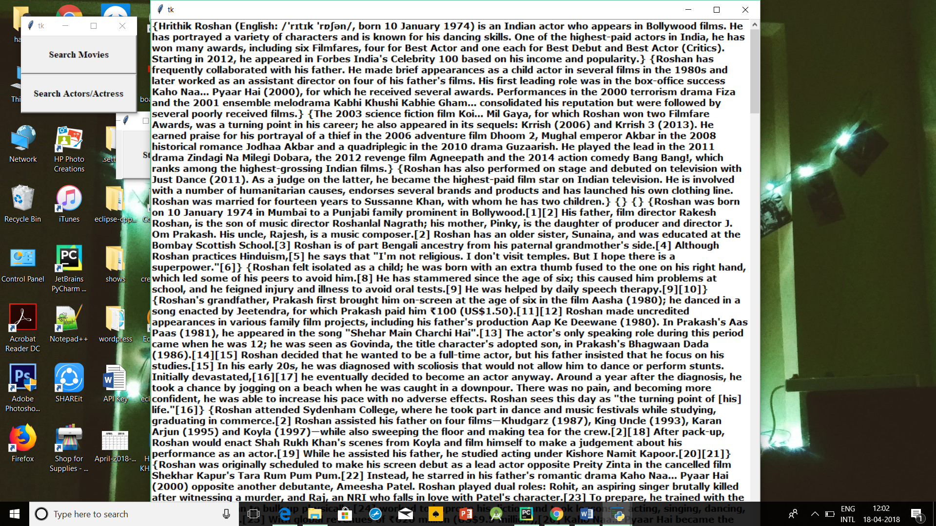

BEAUTIFUL SOUP

Beautiful Soup is a Python library designed for quick turnaround projects like screen-scraping. Three features make it powerful:

1. Beautiful Soup provides a few simple methods and Pythonic idioms for navigating, searching, and modifying a parse tree: a toolkit for dissecting a document and extracting what you need. It doesn't take much code to write an application
2. Beautiful Soup automatically converts incoming documents to Unicode and outgoing documents to UTF-8. You don't have to think about encodings, unless the document doesn't specify an encoding and Beautiful Soup can't detect one. Then you just have to specify the original encoding.
3. Beautiful Soup sits on top of popular Python parsers like [lxml](http://lxml.de/) and [html5lib](http://code.google.com/p/html5lib/), allowing you to try out different parsing strategies or trade speed for flexibility.

Beautiful Soup parses anything you give it, and does the tree traversal stuff for you. You can tell it "Find all the links", or "Find all the links of class externalLink", or "Find all the links whose urls match "foo.com", or "Find the table heading that's got bold text, then give me that text."

SELENIUM

*Selenium automates browsers*. That's it! What you do with that power is entirely up to you. Primarily, it is for automating web applications for testing purposes, but is certainly not limited to just that. Boring web-based administration tasks can (and should!) be automated as well.

Selenium has the support of some of the largest browser vendors who have taken (or are taking) steps to make Selenium a native part of their browser. It is also the core technology in countless other browser automation tools, APIs and frameworks.

PHANTOM JS

**PhantomJS** is a scripted, [headless browser](https://en.wikipedia.org/wiki/Headless_browser) used for automating web page interaction. PhantomJS provides a [JavaScript](https://en.wikipedia.org/wiki/JavaScript" \o "JavaScript)API enabling automated navigation, screenshots, user behavior and assertions making it a common tool used to run browser-based unit tests in a [headless system](https://en.wikipedia.org/wiki/Headless_system) like a [continuous integration](https://en.wikipedia.org/wiki/Continuous_integration) environment. PhantomJS is based on [WebKit](https://en.wikipedia.org/wiki/WebKit" \o "WebKit)making it a similar browsing environment to [Safari](https://en.wikipedia.org/wiki/Safari_(web_browser)) and [Google Chrome](https://en.wikipedia.org/wiki/Google_Chrome) (before Chrome's fork of WebKit evolved into [Blink](https://en.wikipedia.org/wiki/Blink_(layout_engine))). It is [open-source software](https://en.wikipedia.org/wiki/Open-source_software) released under the [BSD License](https://en.wikipedia.org/wiki/BSD_License).[[2]](https://en.wikipedia.org/wiki/PhantomJS#cite_note-license-2)